|  |  |  |  |
| --- | --- | --- | --- |
| C:\Users\nhall9\Desktop\GREEC-logo-a-blue-script.png | | **The Georges River EEC** is a Department of Education and Communities school located in South Western Sydney, one of three EECs in this geographical area of Sydney, and one of a network of 23 EECs across the state. **The Centre aims to** inspire young people to experience and connect with the natural world and encourage the development of positive behaviour changes towards its protection. **Georges River EEC** offers a variety of high quality field work and **environmental and sustainability education** programs for school students **K-12.**  **Our Vision** is to **promote Sustainability Education** and **empower learners** to act responsibly towards their environment.  **To find out more contact our friendly staff;**  **Phone:** 97553189  **Website:** [www.georgesriv-e.schools.nsw.edu.au](http://www.georgesriv-e.schools.nsw.edu.au)  Or follow us on **Facebook** and **Twitter** @GeorgesRiverEEC | |
| T:\Teacher\Pictures\2017\Garths Images\2016\IMG_1154.jpg | **T:\Teacher\Pictures\2017\Garths Images\2016\IMG_1309.jpg** | | **T:\Teacher\Pictures\2017\Garths Images\2016\IMG_1171.jpg** |

**Our Primary Programs include**

|  |  |  |  |
| --- | --- | --- | --- |
| Stage | Subject | Program | Site |
| ES1 | Geography | Places are Important to People | Georges River Environmental Education Centre |
| ES1 | Science | The Needs of Living Things | Georges River Environmental Education Centre  Casula Powerhouse |
| 1 | Science | Natural Environment | Georges River Environmental Education Centre  Simmos Beach  Freres Crossing  Georges River National Park |
| 1 | Geography | Features of Places | Georges River Environmental Education Centre  Simmos Beach  Georges River National Park  Casula Powerhouse |
| 1 | Science | Living World | Georges River Environmental Education Centre  Simmos Beach  Georges River National Park |
| 1 | History | The Past in the Present | Georges River Environmental Education Centre |
| 2 | Geography | Places are Similar and Different | Georges River Environmental Education Centre  Simmos Beach  Georges River National Park |
| 2 | Geography | The Earth’s Environment | Georges River Environmental Education Centre |
| 2 | Science | Living World | Georges River Environmental Education Centre  Simmos Beach |
| Description: https://detwww.det.nsw.edu.au/media/downloads/intranet/thelogo/PublicSchools/Black/DoE_Public%20Schools_Logo_K_RGB.png | | | T:\Teacher\Web site\Pario current website\Copy of EZEC logo.jpg |
| **Primary Programs continued** | | | |
| 2 | History | Community and Remembrance | Georges River Environmental Education Centre |
| 3 | Geogrpahy | Factors that Shape Places | Georges River Environmental Education Centre  Simmos Beach |
| 3 | Science | Living World | Georges River Environmental Education Centre  Georges River National Park |

**Our Secondary Programs include**

|  |  |  |  |
| --- | --- | --- | --- |
| Stage | Subject | Program | Site |
| 4 | Geography | Landscapes and landforms | Georges River Environmental Education Centre |
| 4 | Geography | Water in the World | Georges River Environmental Education Centre |
| 5 | Science | Local Ecosystems | Georges River Environmental Education Centre |
| 5 | Geography | Environmental Change and Management | Georges River Environmental Education Centre |
| 5 | Geography | Australian Communities | Georges River Environmental Education Centre |
| 6 | Biology | Ecosystem Dynamics | Georges River Environmental Education Centre  Casula Powerhouse  Simmo’s Beach  Ingleburn Weir |
| 6 | Investigating Science | Cause and Effect | Georges River Environmental Education Centre  Sublime Point |
| 6 | Earth and Environmental Science | Resource Management | Georgres River Environmental Education Centre |

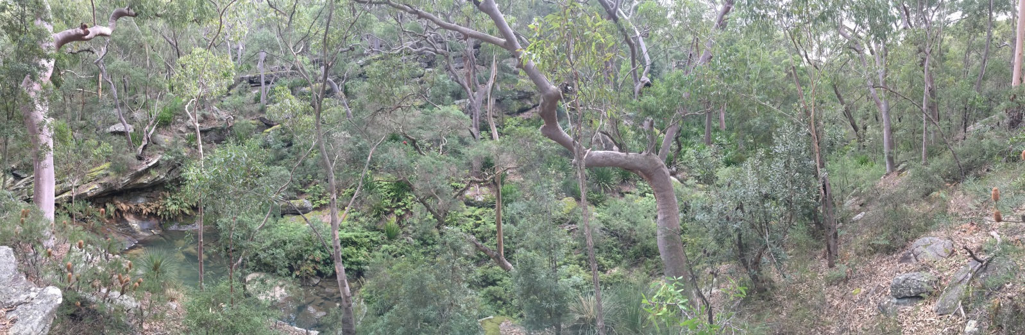

From the headwaters of Darkes Forest to the river mouth at Botany Bay there are excursions taking place all along the beautiful Georges River, there has never been a better time to connect with your local Environmental Education Centre.

**Teachers are talking about us**

“Students gained benefit from using (not just seeing text examples) the great variety of geography tools. Centre staff were very good at encouraging the students to actually OBSERVE the geography around them.” Stage 4 Teacher

“Our students have had an amazing experience that has enriched their learning of living worlds and also incorporated Geography outcomes too.” Stage 2 Teacher

|  |  |
| --- | --- |
| Description: https://detwww.det.nsw.edu.au/media/downloads/intranet/thelogo/PublicSchools/Black/DoE_Public%20Schools_Logo_K_RGB.png | T:\Teacher\Web site\Pario current website\Copy of EZEC logo.jpg |